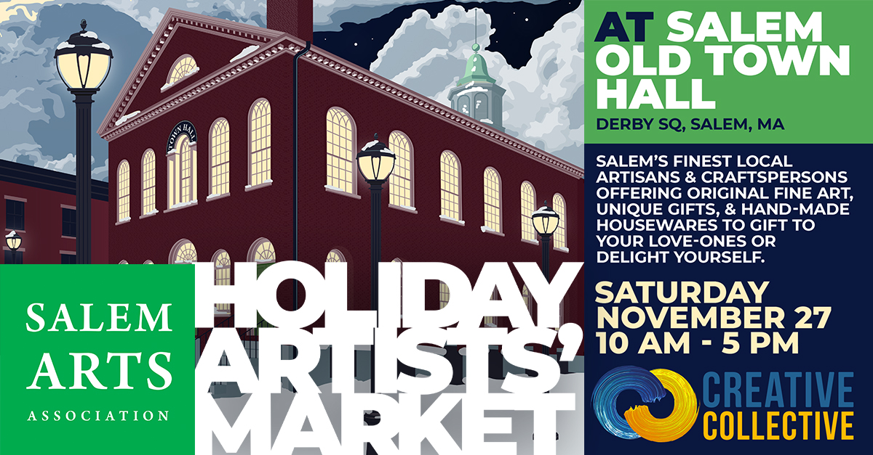
FOR IMMEDIATE RELEASE
November 19, 2021
Contact: James Bostick
Phone: (978) 745-4850
Email: Publicity@SalemArts.org
Web: www.SalemArts.org

Salem Arts Association returns to Salem Old Town Hall for the 8th Annual Holiday Artists’ Market Thanksgiving Weekend

Salem Arts Association is Partnering with Creative Collective to present their 8th Annual Holiday Artists Market at Salem Old Town Hall during Thanksgiving weekend.

The Holiday Artists' Market will take place Saturday, November 27, 10AM to 5PM.

We are planning a festive market featuring more than 50 local artisans with live music and a seasonal theme. We are looking forward to seeing a lively market with all kinds of opportunities for our community to browse and shop for treasures for yourself, friends, and family. Featuring a variety of local artisans and crafters offering original fine art, unique gifts, and hand-made housewares to delight yourself or gift to others.

In addition to our collection of more than 50 vendors we also will host the Salem Boy Scouts Troop 24 who will be selling holiday wreaths.

Salem Gnu Kitchen will also be serving delicious food, beverages, and snacks throughout the day. Salem Gnu Kitchen is a shared use commercial kitchen that helps small businesses grow to their full potential.

Afternoon Music Performances on Saturday provided by Julie Dougherty.
Julie Dougherty has been singing and performing for over 40 years, mostly in the New England area. Singing and playing are her life-long passions and she still writes many of her own tunes. Julie will be joined by her husband Woody Woodward on bass.
For more information visit https://salemarts.org/Holiday-Artists-Market
This project was funded in part through Salem Main Streets by the City of Salem and U.S. Economic Development Administration.

About Salem Arts Association.

Salem Arts Association is an entirely volunteer-run nonprofit arts organization that brings art, in all its forms, to the community and brings the community, in all its diversity, to the arts in Salem, Massachusetts. Since incorporating as a non-profit corporation in 2007, Salem Arts Association has produced hundreds of exhibitions, events, and workshops for Salem’s residents and visitors.

Salem Arts Galleries and Shop are located at 159 Derby Street in Salem MA. Regular gallery hours are 12-6 on Saturdays and Sundays.

###

