Instructions for filling out
Shop Intake Form
- Download the inventory form and fill out all the details using your computer
- If you want your items included in our online shop we need photos based on the criteria below.
- Upload your intake spreadsheet file, images and info online
- OR email your forms and photos to us at shop@SalemArts.org
- Print your spreadsheet to bring it to us at the scheduled take in time.
- IF you cannot print let us know when you send the files and we will have them printed for you at the gallery.
- Make sure your name, artwork title, and price are attached to the back of your artwork.
- Bring your items to the gallery for the scheduled take in time.

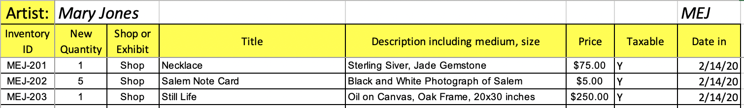
- Artist: Type your full name in the box next to Artist (replace instruction text).
- Initials: Type your initials in the box - e.g. Mary Elizabeth Jones = MEJ. This is also the first part of your inventory ID, (replace instruction text).
- Inventory ID: This is your 3 initials, then a dash, then the month, then item number.
  - For example, Jane Elizabeth Jones with three pieces in February would be: MEJ-201, MEJ-202 and MEJ-203. BE CAREFUL TO BE CONSISTENT WITH YOUR INITIALS.
- New Quantity: Enter the quantity of the item you are submitting
- Shop or Exhibit: select “Shop”
- Title: Provide a title for each item. This information will be displayed on tags and online shop with your name.
  - For Example, "Still Life" by Mary Jones
- Description: Enter a description of the item. Include a detailed description of medium, materials, framing, and size.
- Price: Enter the price in dollars and cents.
- Taxable: Enter Taxable, Yes or No. Clothing is non-taxable. Most other things are taxable.
- Date: Enter the Drop off Date
- File Name: Change the file name to include your first and last name then
- Email the file to shop@salemarts.org
- Deliver inventory to shop, along with a copy of the completed Excel Shop Take-in Form with you on designated drop off day.
Drop Off at Salem Arts
Deliver inventory to shop, along with a printed copy of the completed Shop Take-in Form on designated drop off day or by appointment.
If you can not print please let us know when you send your files and we can print at the gallery during take in times.
- Make sure your name, artwork title, Inventory ID, and price are attached to all of your items.
Email shop@SalemArts.org with questions or to request an appointment.

Photography Guidelines
Salem Arts now has an online shop. Appropriate inventory will be included online of we receive good quality photos of your work. See the Salem Arts Online Shop for examples of what looks best.
- Images should be square.
- Most smart phones or digital cameras will make sufficient images using the square photo option.
- Background should be neutral or dark color, White, Grey or Black are preferred.
- If your items are framed include the frame in your image so people can see what they're buying
- Name your files with your inventory ID that corresponds to each item. Append with A, B, C when submitting multiple images (up to three) for each item. e.g. ABC-123.
- Size should be greater than 1800 pixels wide or tall
- file format must be JPG (JPEG), or PNG
- Focus on framed artwork, jewelry, clothing, 3D items such as ceramics, glass, sculpture, etc. Cards and matted prints will not be made available online
For tips on photographing your work here's a few helpful links.
- How to photograph your art - YouTube
- 4 Steps to Photographing Your Art Like a | Artwork Archive
- 9 Common Mistakes when Photographing your Artwork with an iPhone (and how to fix them)
You can submit your photos via online upload or email. See instructions below for instructions.

Upload or Email your Submissions
Please send your files prior to take in. You may upload or email your files.
You must be "signed in" to your profile to upload online. Look to person icon in the top of this website to sign in.

